**Graduate Deficiency Course CS5590-0003**

**Discrete Structures - Spring 2017**

**Assignment 2**

**Due: 03/08/2017**

1. Are the following graphs isomorphic? If so, prove it with your proper explanation. If not, show an invariant that is different in both graphs.

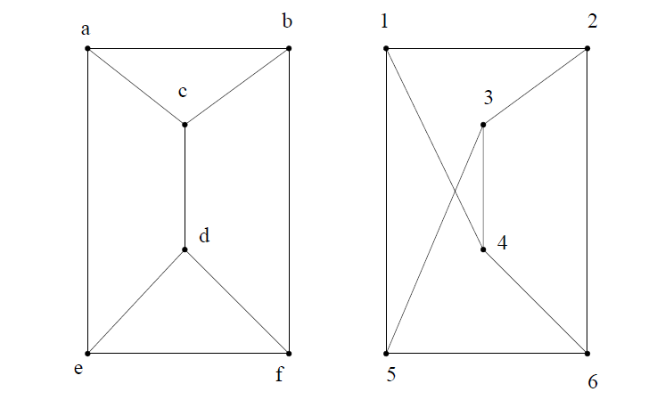

1. For the following graph answer the following.

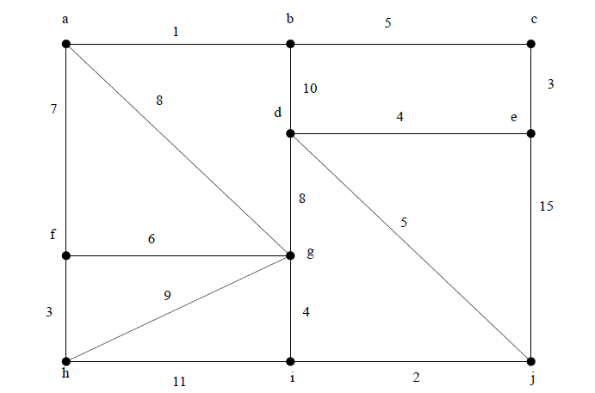

1. Show a minimum spanning tree using Prim’s algorithm. To get credit, you must show the order in which edges are added to the tree.
2. Show a minimum spanning tree using Kruskal’s algorithm. To get credit, you must show the order in which edges are added to the tree.
3. Is the following graph planar? If so, draw it. If not, show a subgraph that is homeomorphic.

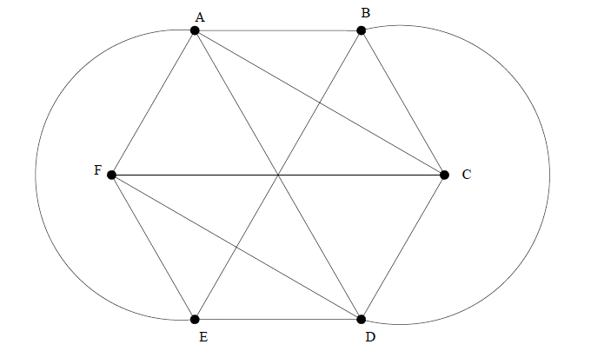

1. Draw the FSA transition table for this following graph and write all its possible accepted and rejected cases. If you couldn’t find any cases, explain why?

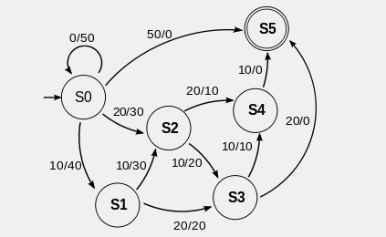

**Report Format:**

1. The report should be in PDF format.
2. Scan your written work and Mobile phone pictures are not acceptable.
3. All references should be included in the report.